MANAGE, Hyderabad and ICAR – IVRI Collaborative Training program on
“Organic Animal Husbandry”
Division of Extension Education, IVRI, Izatnagar-243122, UP during 24-31 October, 2018

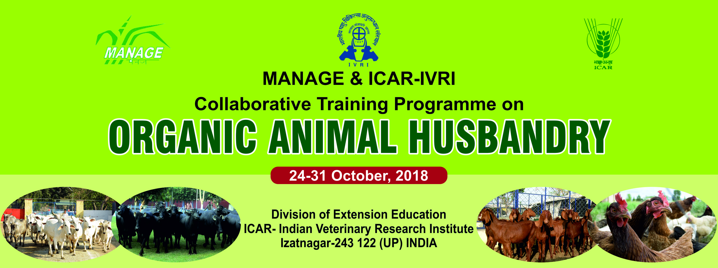

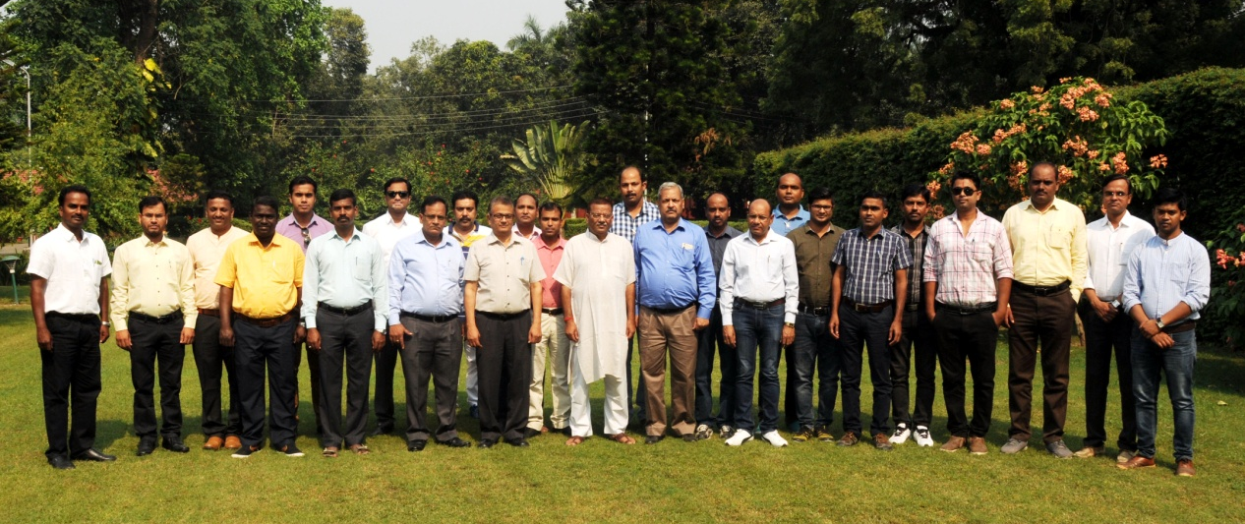

Dr Mahesh Chander overviewing organic farming
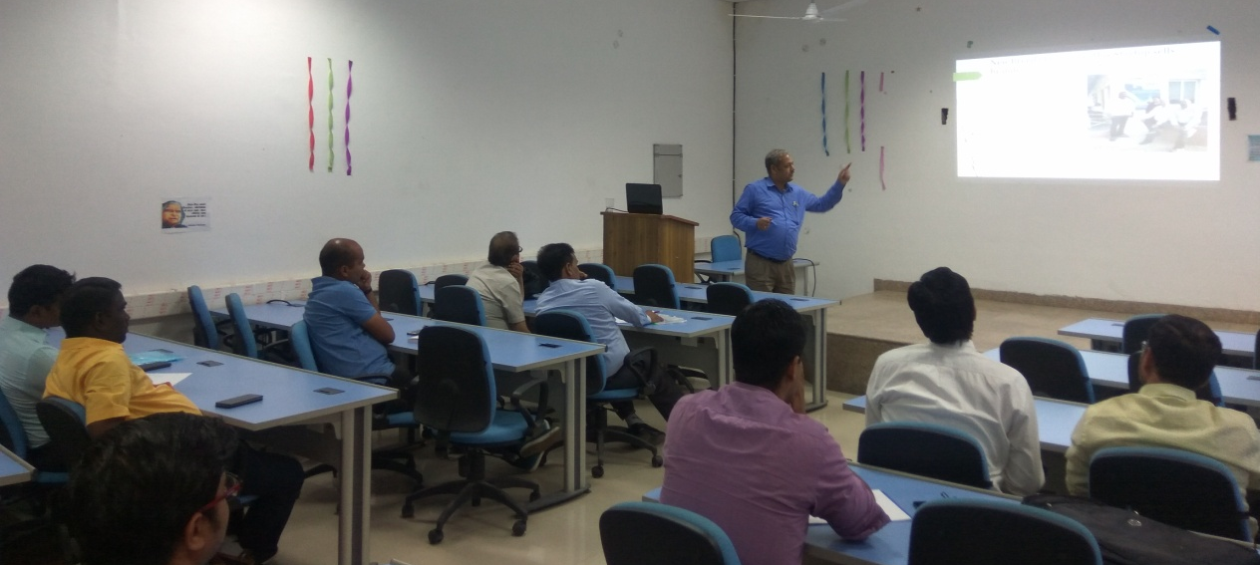

Dr Dwaipayan Bardhan conducting mock audit in Mr Munnalal’s dairy farm
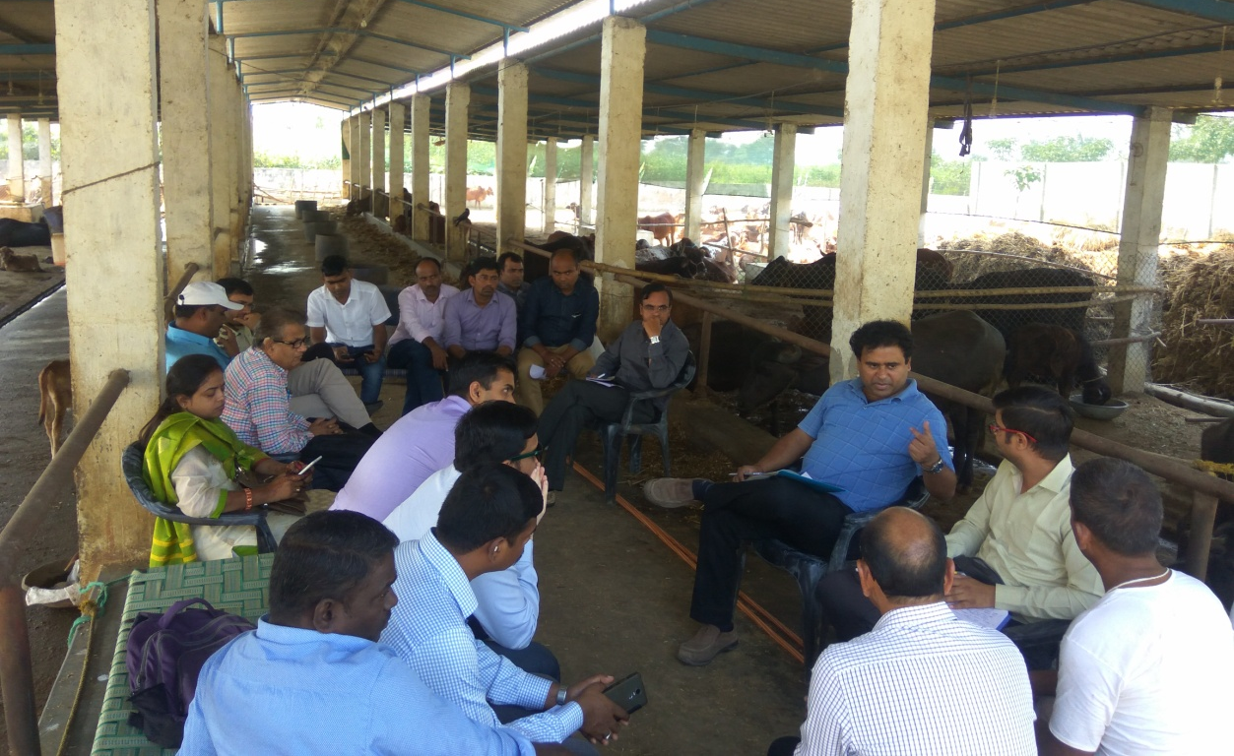

Dr G K Gaur’s guiding participant at dairy farm in IVRI

Dr M Shamim explaining the approach towards organic farming
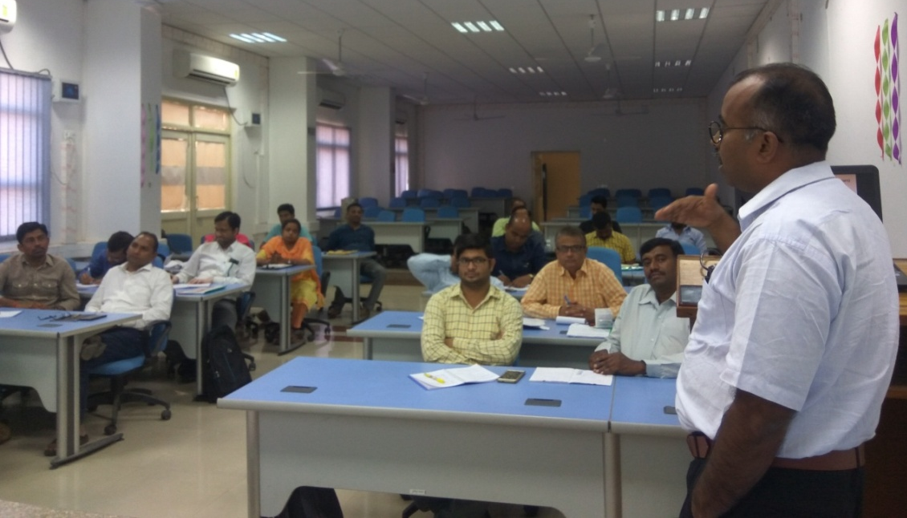

Dr Pijush Kanti Mukherjee explaining sustainable organic fodder production
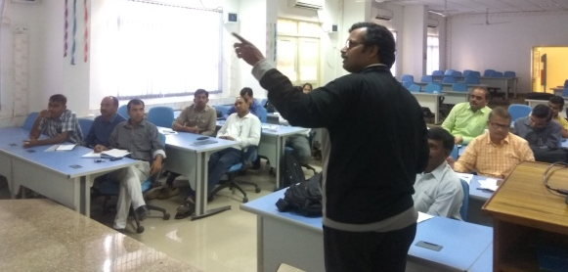

Mr Geson’s lecture at Creation biotech production unit
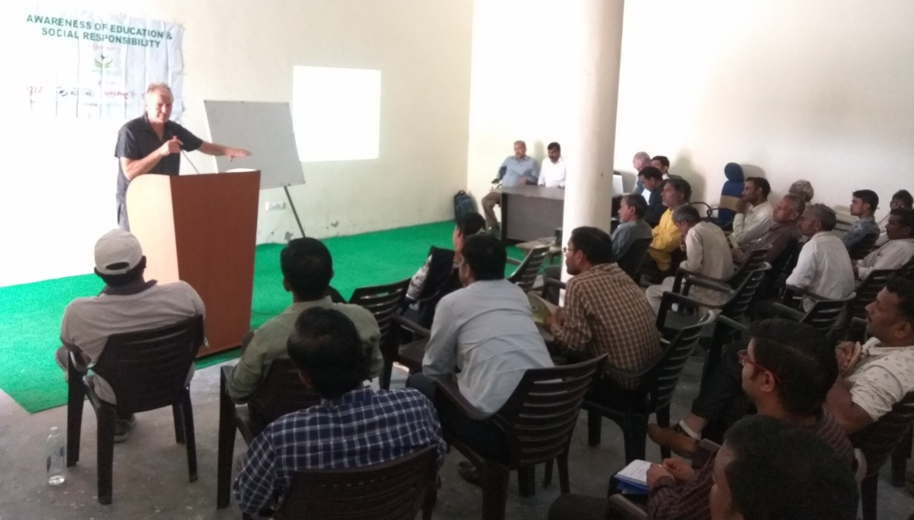

Participants visiting Creation biotech production unit
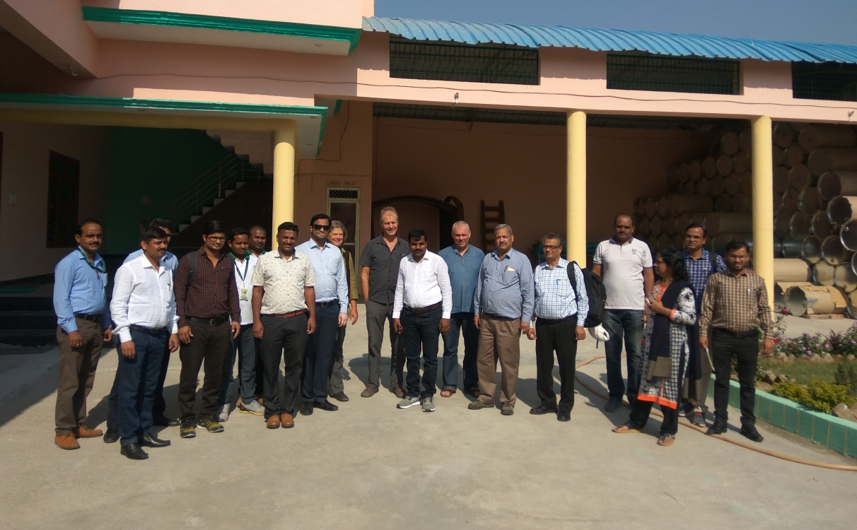

Dr Reena Mukherjee’s session on alternative therapy in making animal healthy
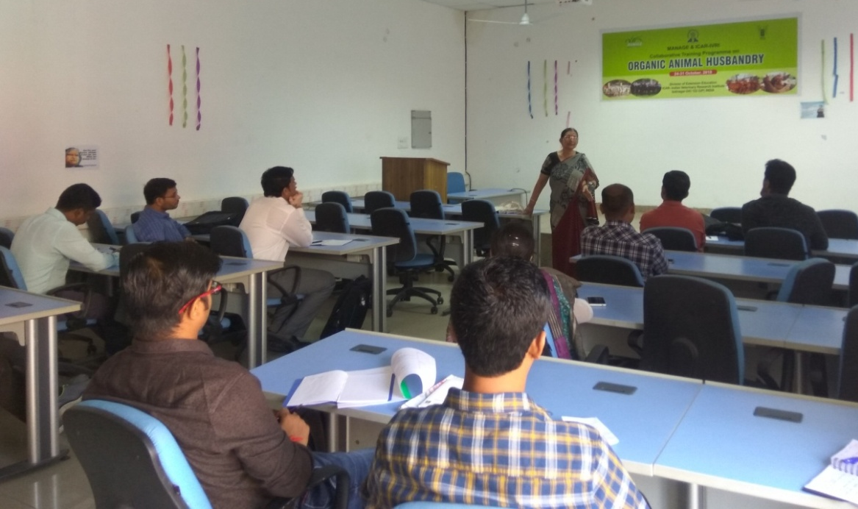

Dr Ran Vir Singh demonstrating Jai Gopal Vermiculture technology
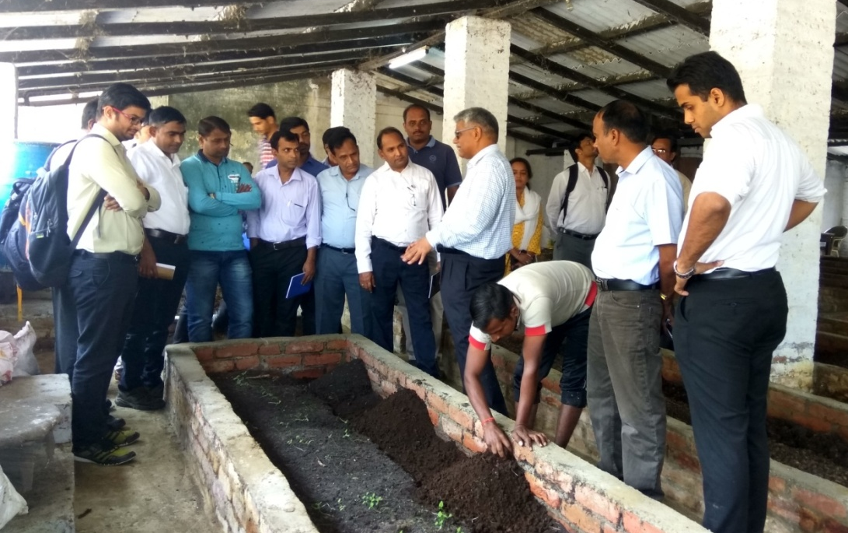

Dr Shahaji Phand explained carrier and entrepreneurship opportunities in livestock sector
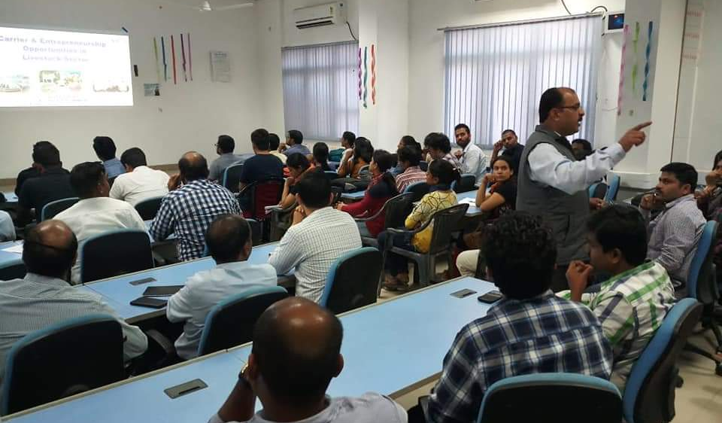

Participants’ interaction with resource persons
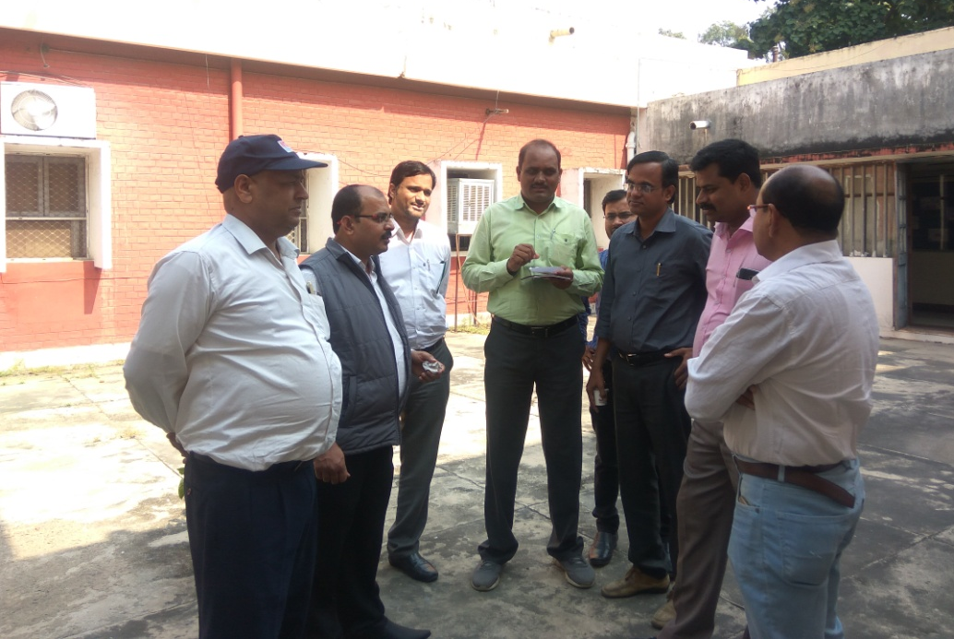

Participant in search of knowledge at ATIC, IVRI
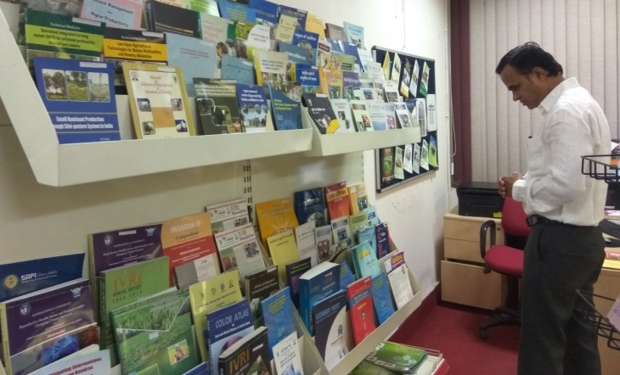

Certificate distribution at valedictory function
