No.68/December 2018

MY MEETING NOTES
MANAGE and ICAR - IVRI Collaborative Training Program on
Organic Animal Husbandry
24-31 October, 2018, Division of Extension Education, IVRI, Izatnagar, UP
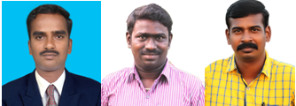
MS Kannadhasan, K Pachaiyappan and R Suresh participated in the Training Program on Organic Animal Husbandry jointly organized by ICAR- IVRI, Izatnagar, and MANAGE, Hyderabad, at Division of Extension Education, IVRI, Izatnagar, during 24-31 October, 2018. They share their experiences here.

CONTEXT

Raising awareness on environmental conservation, sustainable use of natural resources and chemical residue-free healthy food is paving the way towards organic agriculture. In this context, the National Institute of Agricultural Extension Management (MANAGE), Hyderabad, andthe Indian Council of Agriculture Research – Indian Veterinary Research Institute(ICAR-IVRI)organized a Collaborative Training program on ‘Organic Animal Husbandry’ at the Division of Extension Education, IVRI, Izatnagar, Uttar Pradesh,from24to 31 October, 2018. This training program aims to create awareness and develop skills on organic animal husbandry among field extension functionaries, veterinarians, scientists and academicians of ICAR institutes and State Agricultural / Veterinary Universities and other stakeholder institutions. The program imparted training to 25 participants from various institutions.
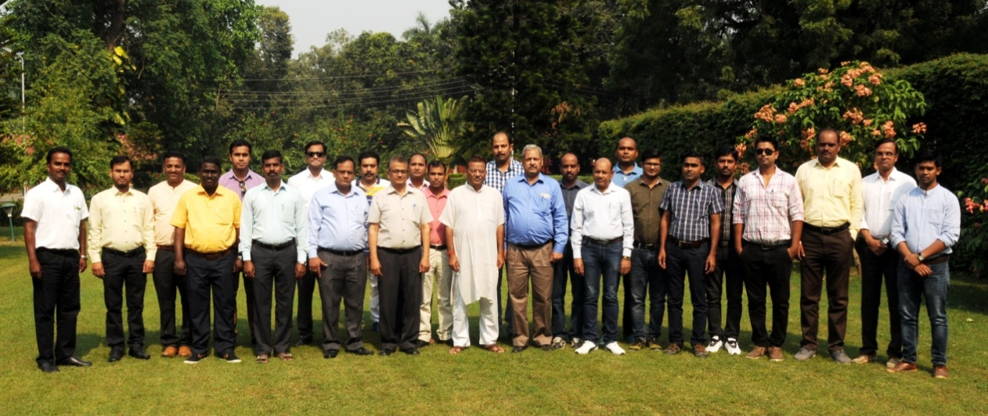

PROGRAM

Session 1: Ice-breaking and expectation setting

The ice-breaking session, conducted by Dr RS Suman, Senior Scientist, Division of Extension Education, IVRI, helped the trainees to overcome barriers in learning and communication and resulted in teambuilding. In the succeeding session trainees individually set their expectations, recalling the needs of their clientele – farmers. As an individual exercise, the trainees contributed remarkably and came up with their expectations from the program.

Session 2: Organic farming nurtures nature: An introduction and overview

Dr Mahesh Chander, Head, Division of Extension Education and Course Director, set the context for the training program by acquainting the trainees with the core theme of the program. In his presentation, he apprised the trainees about organic farming by quoting factual data on certified organic products, showing visuals of the Godson Organic Farm in Bareilly, and sharing the success story of Creation Biotech, Bareilly. He also explained the issues and opportunities for organic cultivation in India. He elaborated on the grassroot approach taken by the Animal Husbandry Department, Sikkim, to become the first organic state in India. In the spirit of contributing towards the objectives of the International Federation of Organic Agriculture Movements (IFOAM), he went on to lay emphasis on animal welfare, environmental protection and resource-use sustainability,all of which are to be adhered to in the organic animal husbandry sector. His session embraced diverse topics such as Global Forum for Rural Advisory Services (GFRAS), bio-tourism, farmgate sale in western countries, livestock value chain, participatory guarantee system, state policy development, certification, labeling, branding and regulatory considerations in organic products, and Jaivikbharat. He sensitized the trainees on how to use the hands-on ‘Information System on Organic Livestock Farming’ developed by IVRI.

Session 3: Can organic farming be economically viable?

This session helped in enlightening the trainees on the economic viability of organic farming. In his presentation, Dr Dwaipayan Bardhan, Principal Scientist, Division of Livestock Economics, Statistics and Information Technology, IVRI, offered a holistic perspective on organic farming and its economic viability within the context of Indian agriculture, citing statistics pertaining to India’s global position in organic farming in comparison with other leading countries. He also threw light on the truth behind the controversies surrounding organic farming. In this enriching session, he spelled out the key challenges in the organic value chain and the ways to tackle it.

Session 4: Rehearse before perform – A mock audit of Mr Munnalal’s dairy farm

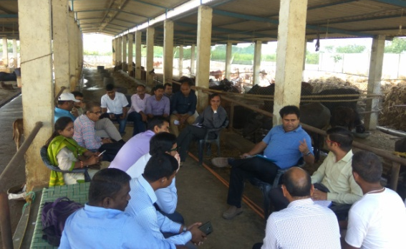
The trainees visited Mr Munnalal’s dairy farm, located 30 km away from Bareilly, to witness the mock audit on the suitability of the farm to be considered as an ‘organic’ farm. The mock audit, conducted by Dr Dwaipayan Bardhan, simulated a real audit which exposed the trainees to the modus operandi for auditing an organic farm. The resource person also defined the standards of organic farming, Organic Management Plan (OMP), and Organic System Plan (OSP).

Session 5: Setting up an organic livestock farm and its management

In his presentation, Dr Gyanendra Kumar Gaur, Principal Scientist, Livestock Production and Management Section, IVRI, spoke extensively on setting up an organic farm and the characteristics of an ideal organic farm. In the next session, he encouraged the trainees to visit farms maintained by Livestock Production and Management Section, IVRI. His expertise and guidance nurtured the trainees’ knowledge on organic farming; and he also clarified their doubts on various practices pertaining to organic farming.

Session 6: An aspiring farmer in pursuit of organic certification

This session, delivered by Dr R Srinivasa Gowda, Evaluator, Aditi Organic Certification Pvt. Limited, Bengaluru, offered information on the requirements of an organic animal farm. He said that an application seeking organic certification should declare for what, and how the farmer is going to run the farm, and the records should clearly state what the farmer did in his/her farm that could allow it to be considered as ‘organic’. Furthermore, he provided information on the procedures involved in getting and renewing organic certification, the steps involved in the certification process for organic agriculture, and the process for converting from non-organic to organic agriculture.

Session 7: Meeting standards everyday by keeping records

Record keeping is a must in organic farming. Referring to the present day trend of transitioning towards more business-oriented farming, Dr Sanjay Kumar, Head, Division of Livestock Economics, Statistics and Information Technology, IVRI, deliberated on why and how the various records have to be maintained as this is mandatory for getting organic certification. He pointed out that records provide documentary evidence of any farm activity, and act as a management tool for improving the farm’s resilience every year. In the spirit of motivating smart agriculture, he also advocatedthe use of Excel sheets for maintaining records.

Session 8: Towards organic – An accelerated approach

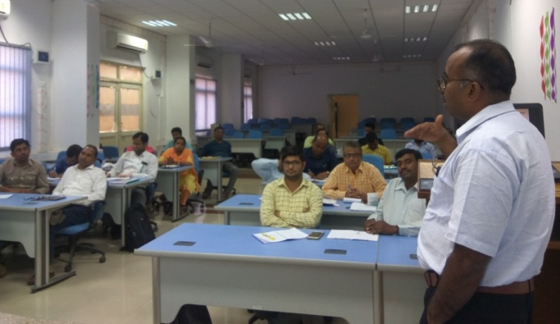
In this session, Dr M Shamim, Associate Scientist, ICAR - Indian Institute of Farming Systems Research, Modipuram, Uttar Pradesh, explained the concept behind the accelerated adoption of ‘towards organic’ for intensive agriculture areas, and ‘certified organic farming’ with a combination of tradition, innovation and science in already existing organic areas. Furthermore, he added value to this session by talking of the lessons he learnt from his own experience and research on organic farming. He went on to speak of the link between soil health and biological diversityin organic farming.

Session 9: Organic fodder production: A sustainable method in organic farming

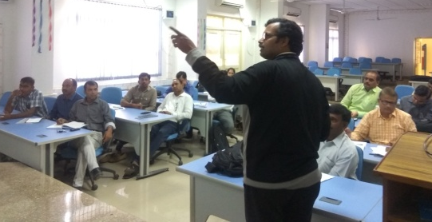
Dr PijushKanti Mukherjee, Senior Scientist, Division of Extension Education, IVRI, described ‘Sustainable fodder production through an organic-based production system’– indicating the substantial increase in demand for organic fodder arising from the exponential increase in organic farming. In his flawless presentation, he delineated the salient features of forage crops, elaborated on bio-intensive farming, explained stage-wise fodder production with picturesque visuals with measurements, and expounded on innovative strategies in organic fodder production.

Session 10: Organic milk and meat: Potential and prospects

Dr Sanjod Kumar Mendiratta, Head, Division of Livestock Products and Technology, IVRI, explained the potential and prospects for organic milk and meat, along with the data retrieved from various institutions. He also highlighted the need for value addition in milk, meat and its by-products so as to maximize the market potential of organic products. The lecture clearly brought out the vital connection between production efficiency and market intelligence in organic farming.

Session 11: Think globally - Act locally - Shine ultimately: The success story of Mr Nihal Singh

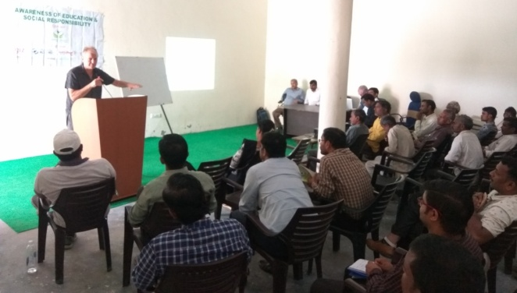
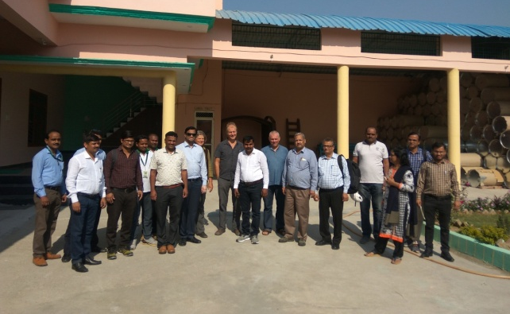
Interestingly, the trainees had an opportunity to get inspired by Mr Nihal Singh, a successful agripreneur who runs Creation Biotech, Bareilly. We visited his organic production unit. He narrated his metamorphosis from a humble farmer to his present spectacular success – highlighting the scope of organic farming. His lecture put forth a sustained account of how perseverance and stewardship led to success. After Mr Singh concluded, Dr Mahesh Chander shared his experience with Creation Biotech and referred to his blog, ‘Minting Organic Money’. The trainees were particularly impressed during the visit when Mr Gero Leson from USA delivered his speech on responsible agricultural production, including social responsibility. The trainees interacted with Mr Gero Leson, Rob Hardy and others from Dr Bronner's Special Operations Team dealing with Dr Bronner's Organic and Fair Trade projects based in USA and present worldwide. This was facilitated by Mr Nihal Singh, MD of Creation Biotech, Bareilly, and his team- the exporter of certified organic products to Dr Bronner’s and several others from Europe. Participants interacted and shared their light moments with Mr Nihal Singh and Mr Leson’s team. They were also able to see a program on ‘Awareness of education and social responsibility’ that was shown to local Kasoomra village farmers as a CSR activity of Creation Biotech, and interacted with them as well.
Session 12: Herbs and alternative therapy for making animals healthy

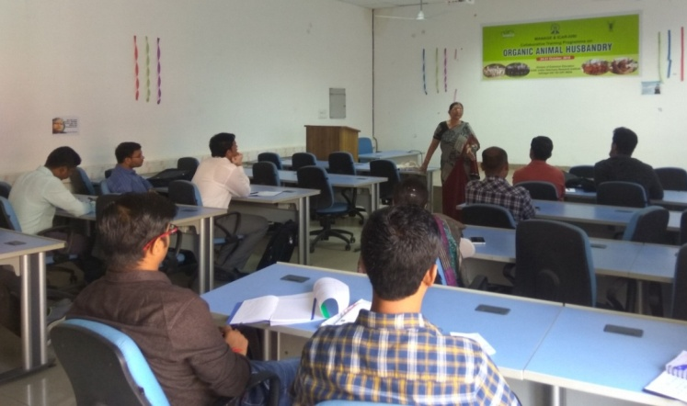
Echoing the increasing awareness on antibiotics, Dr Reena Mukherjee, Principal Scientist, Division of Veterinary Medicine, IVRI, delivered a timely presentation on ‘Organic best management practices and validation of herbal drugs and indigenous technical knowledge (ITK) for organic animal husbandry’. Quoting several successful cases treated with herbal and homeopathic medicine, she pointed out when and where such alternative therapy could be used as supplement or supplant. Her focus extended to biomedical medicine and international standards in treating livestock diseases. This talk was followed with one by Dr Abhijit M Pawde, Principal Scientist, Division of Veterinary Surgery, IVRI, who described options for surgical interventions and alternative therapies in organic animal husbandry. As a continuation to his lecture, he demonstrated acupuncture in treating animals, used at Referral Veterinary Polyclinic – Teaching Veterinary Clinical Complex (RVP-TVCC), IVRI. Conclusively, both these resource persons reiterated the need for a paradigm shift in treating livestock – through the use of herbals.

Session 13: Waste management for greening and sustainability
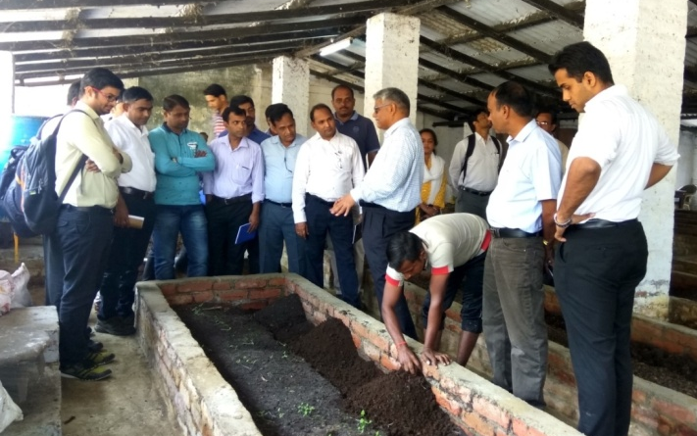
In his presentation on ‘Farm waste management through vermi-biotechnology’, Dr Ran Vir Singh, Senior Scientist, Division of Animal Genetics, IVRI, started with a famous quote “With all waste or pollution, someone somewhere pays for it”. He stressed on the need for composting in animal and farm waste management and for improving soil health, and firmly built up the theory component of waste management for the trainees. He gave a live demonstration on recycling of animal, farm and kitchen waste using Jaigopal vermiculture technology and mechanical biodigestor composting machine. The trainees were exposed to the setting up of vermiculture hatcheries, construction of vermitank and shed, preparation of feed for vermiculture, loading of feed in vermitank, inoculation of Jaigopal vermiculture in vermibed, sprinkling of water, harvesting of vermibiomanure, packaging, storage and application of vermibiomanure in crop production.

Session 14: Extension strategies for organic animal husbandry production

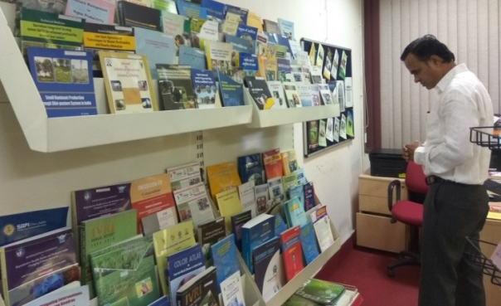
In her well-delivered session, Dr Rupasi Tiwari, Principal Scientist and In-charge of ATIC, IVRI, coherently described the various strategies used in contemporary extension services for propagating organic animal husbandry production. She also reported on the extension activities and initiatives carried out by IVRI; and guided the trainees on how to view the displays and models arranged at the centre. After this session, Dr BP Singh, Principal Scientist, KVK, IVRI, highlighted the significant role of organic livestock demonstration units in providing advisory services to farmers. A group discussion on ‘How to make the extension service delivery system more effective and efficient’ added greatly to the participants’ thinking process and generated ways to strengthen the extension service delivery system. His theoretical session was then fortified with a KVK demonstration farm visit where he explained various farm activities that strengthened the ‘Seeing is believing’ kind of learning in the trainees.

Session 15: Explore yourself to create an opportunity: A note to veterinary graduates

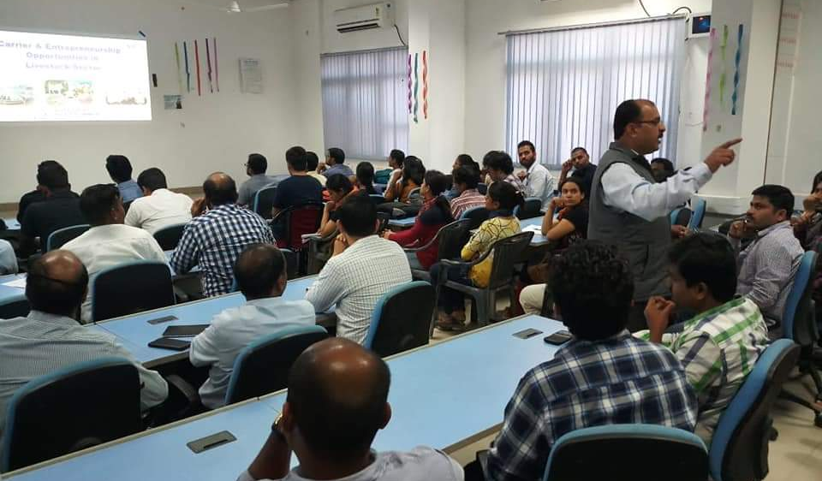
We are thankful to the organizers for arranging a special session on ‘Career and entrepreneurship opportunities in the livestock sector’ delivered by Dr Shahaji Phand, Assistant Director (Veterinary Extension), MANAGE, Hyderabad. The lecture was a step forward in creating awareness about unconventional and emerging opportunities that can help trainers arouse motivation in aspiring veterinary graduates.

EVALUATION –TAKE A STEP BACK TO MOVE AHEAD

Utilizing the training as a learning platform first year PhD students of the Division of Extension Education, IVRI, conducted a pre- and wrap up evaluation using a structured questionnaire with an option for giving shrewd suggestions and observations that can be used to improve training management in future. The participants’ take home messages are summarized below.

Take home messages

- Need, importance, scope, issues and opportunities of organic farming
- Practices to be adopted in organic farming
- Records to be maintained by organic farms
- Procedures involved in getting and renewing organic farming certification
- Extension strategies using contemporary extension aids to propagate organic farming
- Breed suitability in organic animal husbandry
- Do’s and don’ts in treating animals that are reared organically
- Metamorphosis involved in converting a non-organic livestock farm into an organic farm
- Various stakeholders and institutions involved in organic farming
- Ethics and morality: abiding by the laws of the land while enhancing animal welfare
- Value addition and value chain in organic animal farming
- Past and current research in organic farming

VALEDICTORY SESSION

In his valedictory address, the chief guest, Dr RK Singh, Director, IVRI, exhorted field functionaries to help farmers produce clean and green agricultural products so that they can augment their livelihood. Following this, the chief guest congratulated the trainees, and handed out participation certificates. Three representative trainees shared their experiences and registered their appreciation of the training program. In his program report, Dr Mahesh Chander, the Course Director, presented an overview of organic farming and summarized the whole training program with special focus on the various issues addressed during the training. He also shared his experiences with the trainees during the program and detailed the trainees’ involvement during field visits. Dr RS Suman, Senior Scientist and Course Coordinator, thanked everyone associated with this program, especially the participants, faculty and staff for their overall cooperation that led to successful completion of the training program.

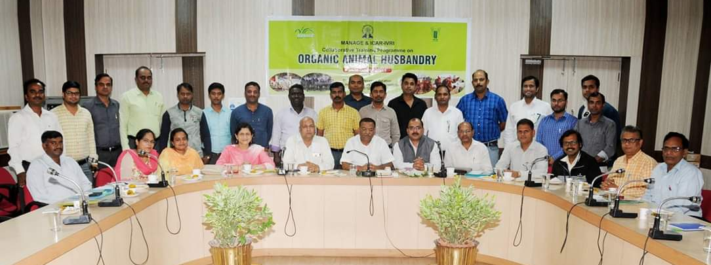
IMPRESSIONS

- The smooth training management clearly reflected the meticulous planning made by the organizing team. Information about topic, timing, venue, transport and refreshment arrangements were promptly updated through the WhatsApp group formed for the use of the trainees and organizing team. This group continues to act as a platform for sharing experiences and views of the group members, even after the close of the training program.
- Twenty-five trainees (including two women) representing ICAR institutes, state departments of Animal Husbandry, SAUs, SVUs, and Certification bodies of six states viz., Uttar Pradesh, Uttarakhand, Maharashtra, Tripura, Karnataka and Tamil Nadu formed a group for the purpose of sharing the learning acquired during the programme. They were encouraged to reflect on the suggestions and ideas generated during the course of the entire program.
- The resource persons were proficient in content delivery – using an appropriate mix of training aids and methods which fortified the learning environment. Subjects covered related to soil, crop, animals, and human interventions, and these paved the way to a holistic understanding of organic farming.
- Learning in the field is always interesting to students of any kind. Therefore, exposure visits organized as part of the training programme helped the trainees to develop insights on organic farming, and the role it plays in tackling the mounting global demand for food.
- All the trainees learned to share their learning and experiences leading to much knowledge-sharing and mutual discovery. Apart from the diverse digital information circulated among trainees through WhatsApp, they were also provided with a book published by ICAR on ‘Organic Livestock Farming’ authored by Dr Mahesh Chander and Dr B Subrahmanyeswari. It will remain as a permanent document and continue to reinforce the information on organic farming in future.
- A well-established educational institution has many avenues to infuse knowledge into all kinds of knowledge-seekers. The Indian Veterinary Research Institute carried out this function liberally through a variety of agencies viz., the National Library for Veterinary Science (NLVS), computer lab, clinics, farms, fodder plots, communication centre, ATIC, museum and Wi-Fi facilities. The participants effectively utilized their leisure time constructively using these facilities. Additionally, sports and entertainment facilities available inside the campus amused the participants occasionally. Other elements, such as the homely accommodation, genial hospitality, delicious food and pleasant weather ensured all-round comfort.
- Resource persons were frequently seen learning from other resource persons’ sessions. It showed the open-minded attitude of the resource persons, leading one to think of famous quotes, such as “Learning is an endless process” and “Each one teach one”.
- We take this opportunity to offer some suggestions for improving the training program. We are very thankful, and request the organizing team to conduct such training at regular intervals. It would empower field functionaries to provide the required rural advisory service to farmers in the mission of propagating organic farming. Further, duration of the training program could be extended, so that participants can visit many more organic farms and institutions and interact with more farmers who are successful in organic farming.
- As a whole, the training program clearly did the intended without any doubt. Cherishing all these, on behalf of all fellow trainees, we take the opportunity to convey our sincere gratitude to MANAGE and ICAR-IVRI for organizing this training program. This worthwhile training can move the participants a step forward towards the development of organic animal husbandry alongside organic crop farming in more scientific ways – towards the sustainable agricultural development of India. Thomas Paine said “The mind once enlightened cannot again become dark.” We hope to use the learned knowledge and skill gained here in providing required advisory services to needy and aspiring farmers so as to propagate organic farming.

MS Kannadhasan, Assistant Professor, Veterinary University Training and Research Centre, Dharmapuri-636701, Tamil Nadu, is currently pursuing a PhD in Veterinary Extension Education at Division of Extension Education, ICAR- Indian Veterinary Research Institute, Izatnagar-243122,UP, India.
(Email: vetmskdhasan@gmail.com)

K Pachaiyappan, is a Scientist, with the Southern Regional Research Centre, ICAR - Central Sheep and Wool Research Institute, Mannavanur, Kodaikanal- 624103, Tamil Nadu, India.
(Email: pachaiyappank@gmail.com)

R Suresh, is an Assistant Professor, at the Department of Animal Nutrition, Veterinary College and Research Institute, Orathanadu - 614625, Tamil Nadu, who is currently pursuing a PhD in Animal Nutrition at the Division of Animal Nutrition, ICAR- Indian Veterinary Research Institute, Izatnagar-243122,UP, India.
(Email: sureshbpmynepolean@gmail.com)
